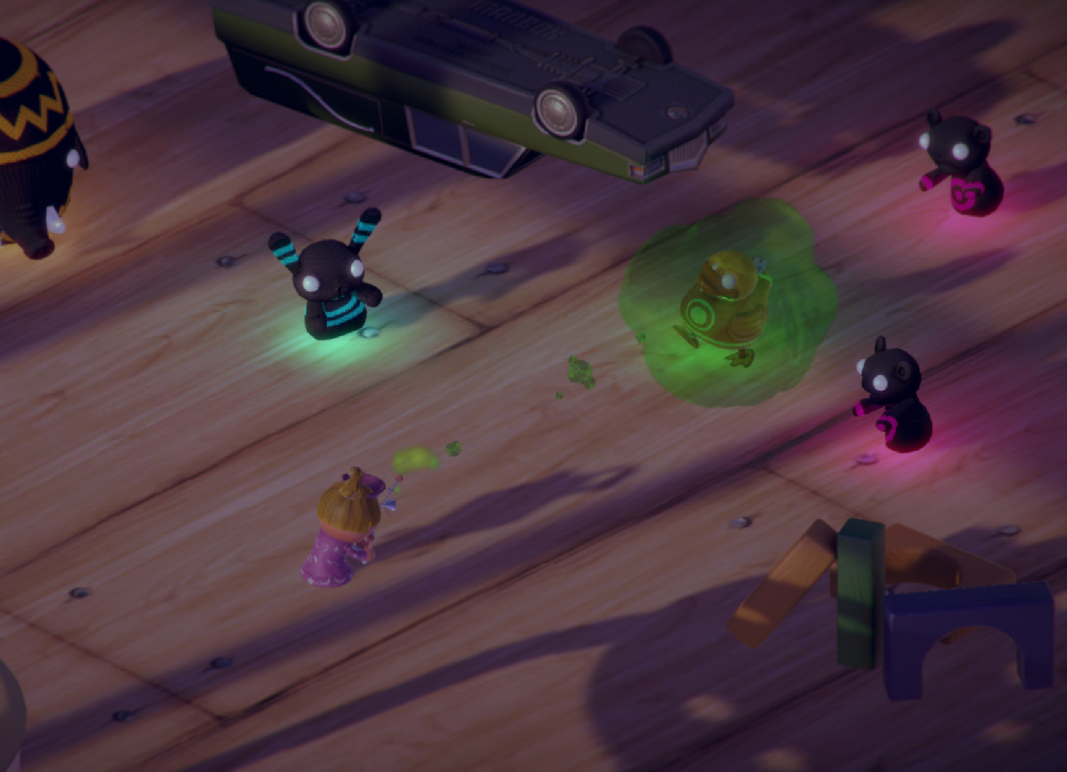

Veggie Revenge

**GAME DESIGN DOCUMENT**

### Unity Certified Developer Courseware

Índice

Contents

Unity Certified Developer Courseware 1

Visión general del juego 3

Concepto principal del juego 3

Puntos de venta 3

Requisitos mínimos 4

Principales competidores 4

Sinopsis 5

Objetivo principal del juego 5

Reglas del juego 5

Estructura del juego 5

Gameplay 6

Game Camera 7

HUD 7

Player 8

Player Characters 8

Player Metrics 8

Player States 8

Player Weapons 8

Character Line-up 9

NPC Enemies 9

Enemy States 10

Enemy Spawning 10

NPC Allies 10

Sheep 10

Ally Spawning 10

Art 12

Setting 12

Level Design 12

Audio 13

MVP (Minimum Viable Product) 14

Wishlist 14

#### Equipo desarrollador del juego

PRODUCTOR

DISEÑADORES

SYSTEMAS

PROGRAMADORES

ARTISTAS TÉCNICOS

ATISTAS DE SONIDO

PROBADORES

# Visión general del juego

Título: Veggies revenge

Plataforma: PC Jugador local + iOS & Android   
Género: Endless 3D survival shooter Clasificación: (10+) ESRB

Público objetivo: Jugador casual (Edades entre 12 - 99)

Fecha de lanzamiento: Pendiente, 2024

Zombie Toys is a third-person endless survival arcade game where the Player is a child (boy or girl) who has awoken to discover that all their toys have come to life and become zombified.

Now the Player must survive by avoiding the zombie toy enemies. They may accrue points by utilizing a special remote control toy to attack the zombies in one of four different ways (Lightning Ray, Freeze Ray, Stink Bomb, and Slime). Using points accrued through the various attacks, the Player may also spawn Allies, which currently include a Sheep. The Allies will help the Player avoid the zombie toys and survive in the game.

# Concepto principal del juego

Zombie Toys sets the Player in a magnified children’s room where he/she is attacked by their own zombified toys. Zombified plush animals are coming from everywhere, looking for you. Fight back with your remote control toy! Use the Lightning Ray to blast them, the Freeze Ray to temporarily immobilize them with ice, drop a Stink Bomb in their way and watch them run, and launch a Slime attack to keep them busy.

# Puntos de venta

* Pendiente
* Pendiente

# Requisitos mínimos

PC, MAC AND LINUX STANDALONE

ANDROID

.

# Principales competidores

Survival Shooter by Unity Technologies

# Sinopsis

In a bad dream, all your plush toys have become zombified. You are the sleeping boy or girl who finds themselves surrounded by these creatures and under attack — there is no escape, you must fight back!

# Objetivo principal del juego

The objective of the game is to survive for as long as possible, while attacking Enemies and scoring points.

# Reglas del juego

The game level is a closed environment set in a child’s room where the Player is attacked by fluffy zombified toys. The Player can move around and attack these Enemies with 4 different Weapons (see *Weapons*). In this level, there are different spawn points from which the Enemies originate. Each Enemy has a different behavior and will try to defeat the Player (see *Enemies*). The Player scores points by killing Enemies: the number points earned depends on the Enemy type. After collecting a specific number of points (see *Allies*), the Player can spawn an Ally who will help him for a limited amount of time.

# Estructura del juego

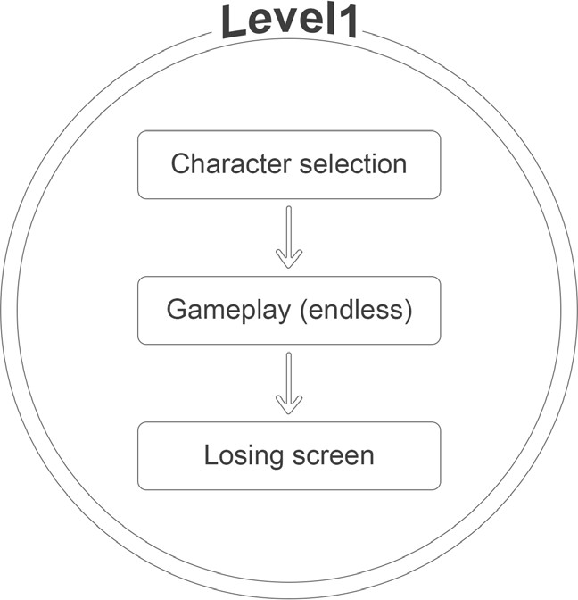

# Gameplay

Controles (PC)

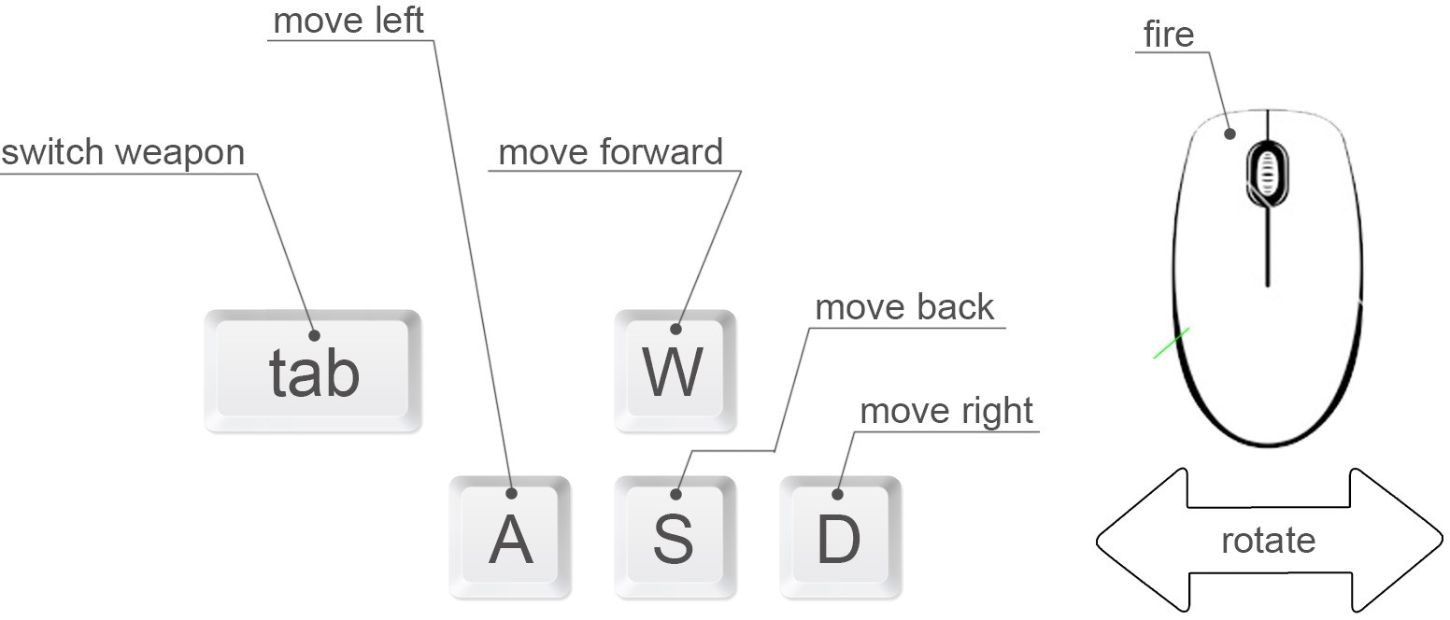

Controles (Mobile)

With touch control, the Player will use two fingers to move the character, aim, and attack. The first finger that presses the screen will move the character, while the second finger that presses the screen will make the Player attack (i.e. fire/shoot) in that direction.

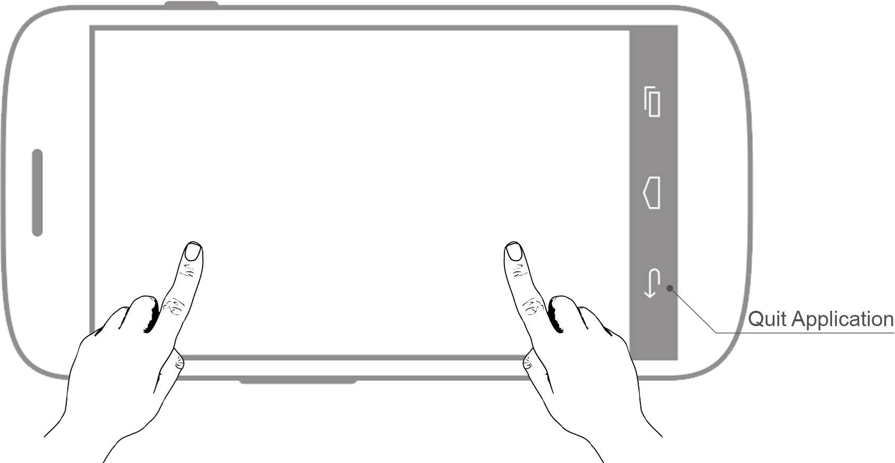

## Game Camera

When the game starts, the camera will focus on the two characters the Player can choose from. The camera will remain still while the Player chooses a character to play with.

After the selection is made, the camera will turn 180 degrees and will continue following him/ her from a fixed point of view. The camera will not rotate with the Player’s movement.

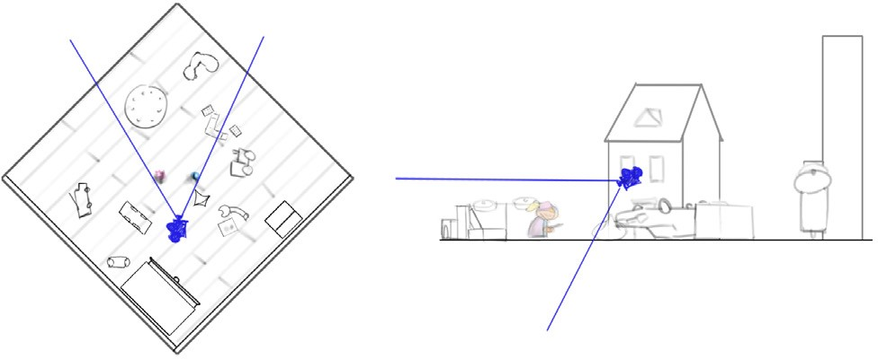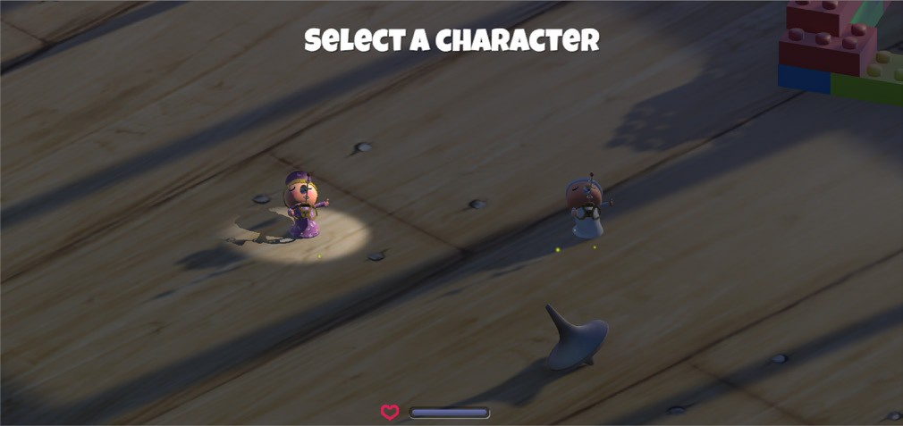

The background will be seen from a 3/4 perspective but for convenience it will be rotated by 90 degrees so that the camera can use the global coordinate system.

The camera will not turn when the Player does, so we get to see him/her from different angles as the scene maintains the same camera view.

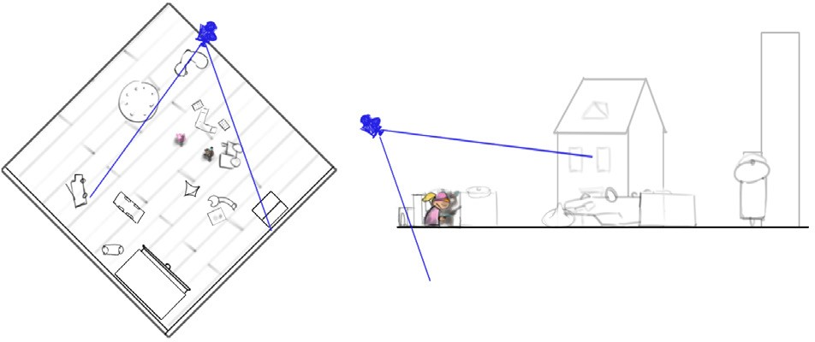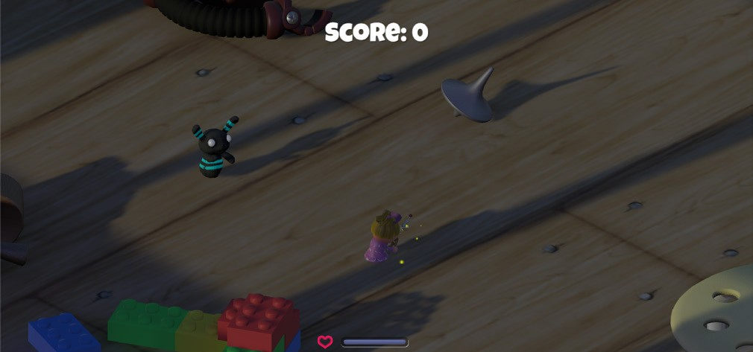

## HUD

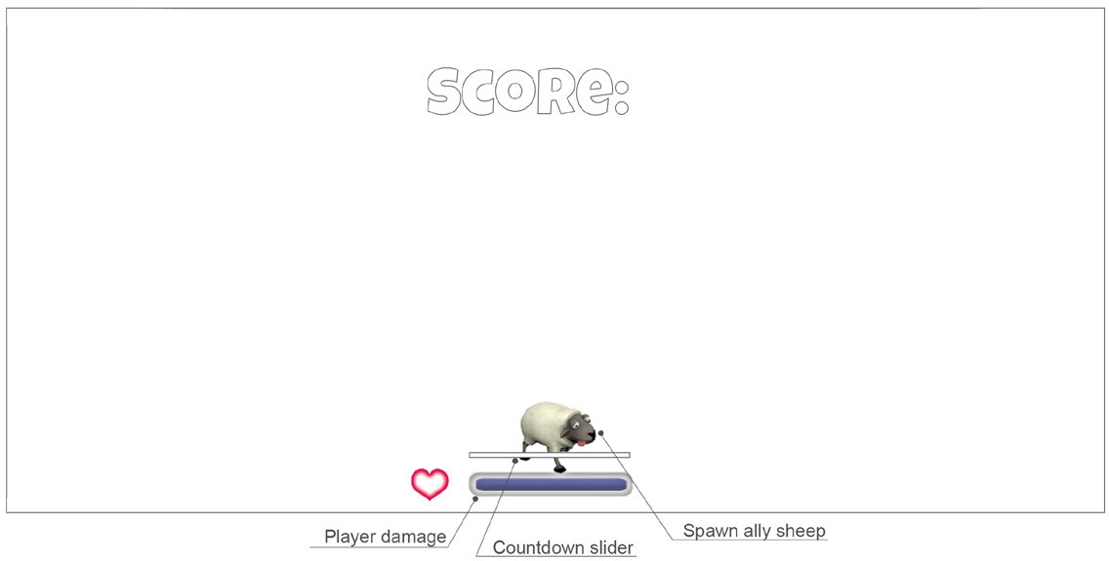PLAYER DAMAGE

Indicates the amount of life the Player has

COUNTDOWN SLIDER

Displays the Weapon recharging time (time depends on Weapon)

SPAWN ALLY SHEEP

Displayed when the Player reaches certain amount of points. When clicked, an Ally Sheep will be spawned into the game.

# Player

## Player Characters

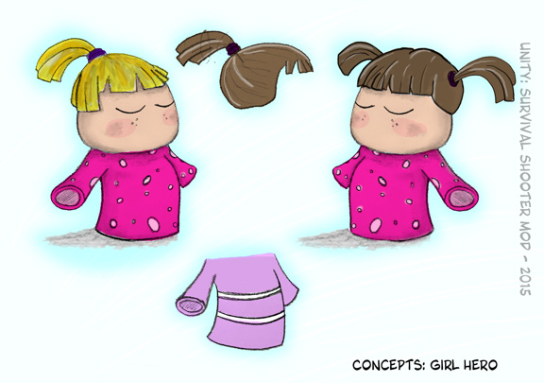

The boy and girl live a wonderful life at their age of 4. They have a great room where they sleep at night. Problem is, their parents have given them too many plush animals without noticing that at night they all become zombified!

## Player Metrics

Speed: 6

Max Health: 100

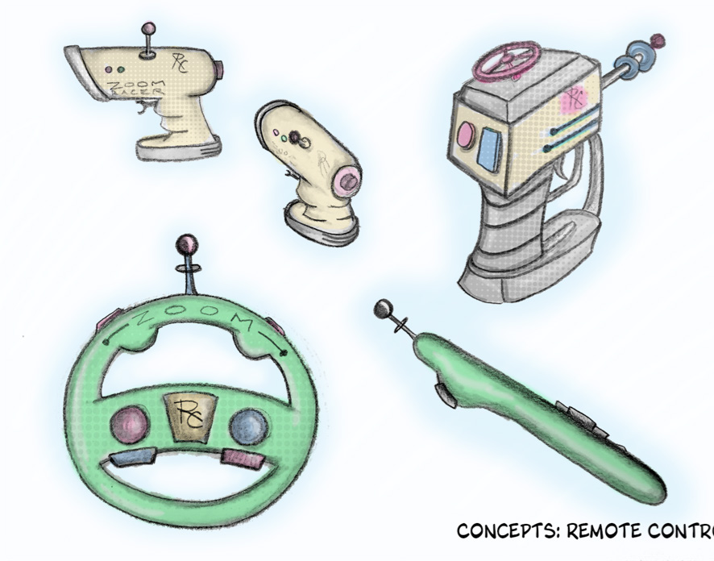

Attack Damage: N/A

Time to attack: Depending on weapon

## Player States

Idle: The idle state is s cycled animation where the Player is yawning. It plays back when the Player remains still.

Move: The movement animation will cause the character to bounce with little jumps. It will be triggered when the Player moves the character.

Death: The death animation will make the character fall backwards when their life reaches zero.

## Player Weapons

The Player has 4 different Weapons to attack the Enemies, each with a different effect.

|  |  |  |  |  |
| --- | --- | --- | --- | --- |
| WEAPON | DESCRIPTION | EFFECT ON ENEMY | COLLDOWN | RETICLE |
| Lightning Ray | Fires a Lightning Ray effect from the Player RC in the direction of the mouse cursor | Restores 50 to the health of the Enemy | 1 | No |
| Freeze Ray | Fires a Freeze Ray effect from the Player RC in the direction of the mouse cursor | Freezes a maximum of 20 Enemies, so they cannot move | 0 | No |
| Stink Bomb | Launches a Stink Bomb effect to the position of the mouse cursor | Causes the Enemies (in a distance of 9u) to turn around | 5 | Yes |
| Slime | Launches a Slime effect in the direction of the mouse cursor | Launches a slime ball that sticks to the  Enemy and hurts them | 3.5 | Yes (snaps to closest Enemy) |

# Character Line-up

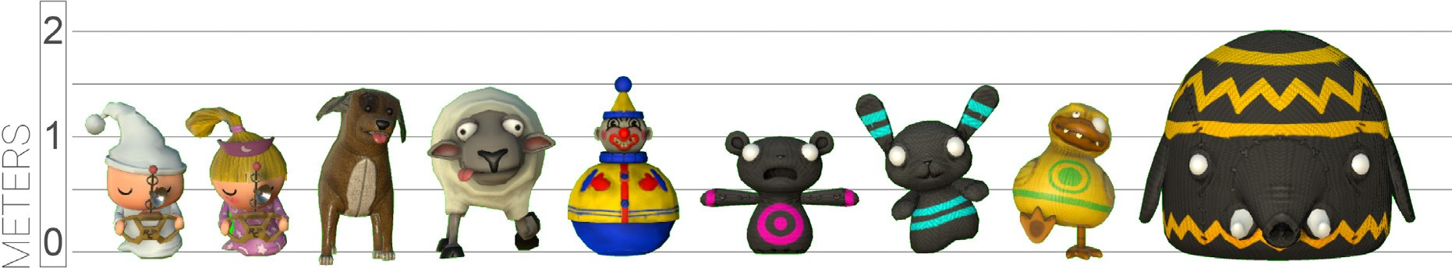

# NPC Enemies

The Enemies spawn from different spawn points located in the environment (see *Level Design*). They are constantly searching for the Player. When they get close to the Player, they attack, producing different amounts of damage, depending on their type. All of the Enemies react equally to the different Weapons (see *Weapons*) and to the Allies (see *Allies*).

Clown

|  |  |  |  |  |
| --- | --- | --- | --- | --- |
| SPEED | MAX HEALTH | SCORE VALUE | ATTACK DAMAGE | TIME TO ATTACK |
| 3.5 | 150 | 25 | 30 | 1.5 |

ZomBear

|  |  |  |  |  |
| --- | --- | --- | --- | --- |
| SPEED | MAX HEALTH | SCORE VALUE | ATTACK DAMAGE | TIME TO ATTACK |
| 3.5 | 100 | 10 | 10 | 0.5 |

ZomBunny

|  |  |  |  |  |
| --- | --- | --- | --- | --- |
| SPEED | MAX HEALTH | SCORE VALUE | ATTACK DAMAGE | TIME TO ATTACK |
| 3.5 | 100 | 10 | 10 | 0.5 |

ZomDuck

|  |  |  |  |  |
| --- | --- | --- | --- | --- |
| SPEED | MAX HEALTH | SCORE VALUE | ATTACK DAMAGE | TIME TO ATTACK |
| 3.5 | 120 | 20 | 20 | 1 |

Hellephant

|  |  |  |  |  |
| --- | --- | --- | --- | --- |
| SPEED | MAX HEALTH | SCORE VALUE | ATTACK DAMAGE | TIME TO ATTACK |
| 3.5 | 200 | 50 | 35 | 2 |

## Enemy States

All Enemies possess the same behavior and states, as described below:

Idle: The Enemies play the Idle state, only when the Player is dead, while seeing the losing screen, and before restarting the level.

Move: While the Player is alive, all enemies will be in the Move state, heading in the direction of the Player or Ally.

Death: Death happens when the Enemy sustains too much damage from an attack.

## Enemy Spawning

Each Enemy has its own spawn point (see *Level Design*) and will spawn at a certain rate. An Enemy will only spawn if there are fewer Enemies of that particular type than others in the scene at that moment.

|  |  |  |  |
| --- | --- | --- | --- |
| ENEMY | SPAWNPOINT | SPAWN RATE | MAX ENEMIES |
| ZomBunny | ZomBunnySpawnPoint | 5 | 4 |
| ZomBear | ZomBearSpawnPoint | 6 | 3 |
| Hellephant | HellephantSpawnPoint | 10 | 2 |
| ClownSpawnPoint | ClownSpawnPoint | 15 | 2 |
| ZombieDuck | DuckSpawnPoint | 10 | 2 |

# NPC Allies

Allies are animals the Player character trusts. They are in the game to help the Player survive. After the Player accumulates the required amount of points, the Player may elect to spawn a Sheep Ally. Once spawned,

the Player will lose some points and the Sheep Ally will assist the Player for a finite period of time. When spawned, all the Enemies will be attracted to the position of the Sheep, as the Sheep moves through the scene. At this time, the Player will be able to attack the Enemies without being attacked in return.

## Sheep

|  |  |  |
| --- | --- | --- |
| SPEED | DURATION | COST |
| 3.5 | 10 seconds | 30 points |

## Ally Spawning

When the Player reaches a specific score (see *NPC Allies* sheet), a button will appear in the GUI with the shape of the Ally. When clicked, the Ally character will be spawned from its spawn point (see *Level Design*).

# Art

## Setting

The game takes place in the children’s room. Because the children have been shrunk down to the size of the toys, everything in their surrounding environment looks very large. A collection of static toys dispersed around the floor serve as obstacles.

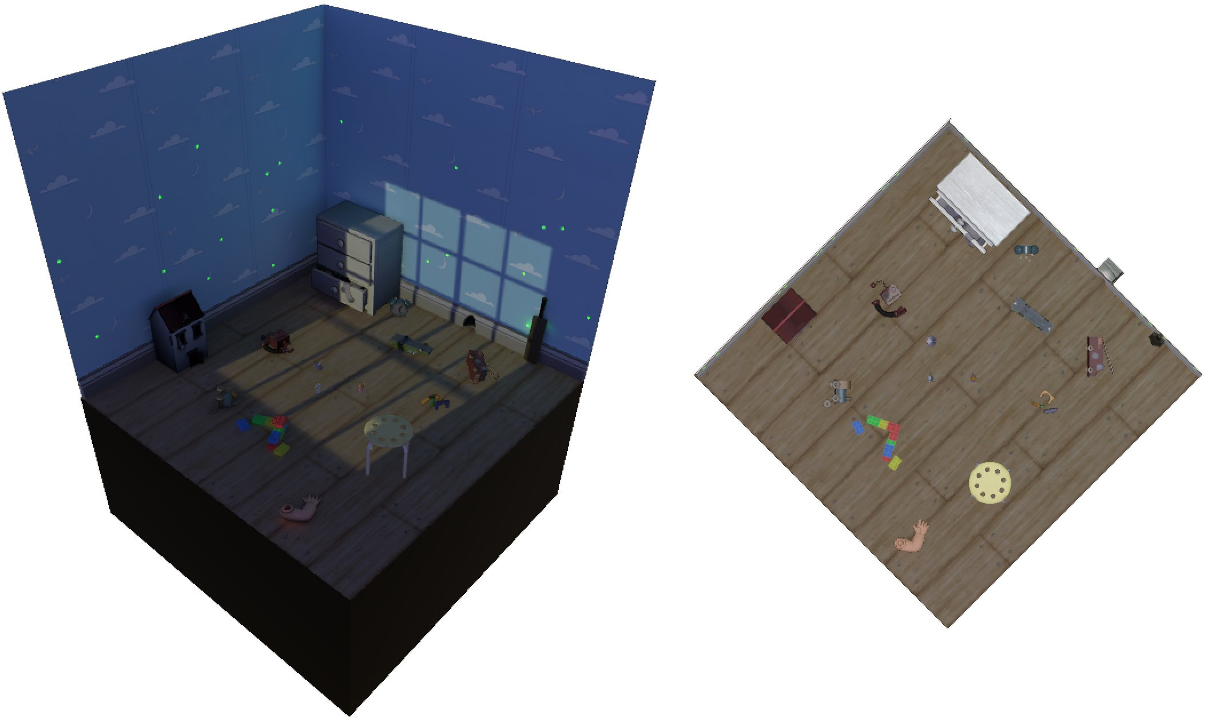

# Level Design

The level consists of the children’s room, with toys (dispersed around the floor) that will act as obstacles for the Player and for the Enemies. The toy elements (that serve as props) are placed so the Player can not be occluded easily when they move behind one.

There will be four (4) different spawn points in the level. Each spawn point is displayed as a green circle in the scheme (*shown right*). Enemies will appear from these spawn points at a precise rate.

# Audio

|  |  |  |
| --- | --- | --- |
| NAME | CATEGORY | DESCRIPTION |
| music_rev1_loop_01 | Background music | Plays during the game |
| Lightning Zap | FX | Lighting Attack fire |
| wpn_elec_attack_01 | FX | Lighting Attack fire, variance 1 |
| wpn_elec_attack_02 | FX | Lighting Attack fire, variance 2 |
| wpn_elec_attack_03 | FX | Lighting Attack fire, variance 3 |
| wpn_elec_hit_01 | FX | Lighting Attack hits something, variance 1 |
| wpn_elec_hit_02 | FX | Lighting Attack hits something, variance 2 |
| wpn_elec_hit_03 | FX | Lighting Attack hits something, variance 3 |
| wpn_gas_attack_01 | FX | Stink bomb Attack fire |
| wpn_gas_attack_loop_01 | FX | Stink bomb Attack smoke |
| wpn_gas_equip_01 | FX | Optional (sounds when weapon is selected) |
| wpn_gas_hit_01 | FX | Stink bomb Attack hits something, variance 1 |
| wpn_gas_hit_02 | FX | Stink bomb Attack hits something, variance 2 |
| wpn_gas_hit_03 | FX | Stink bomb Attack hits something, variance 3 |
| wpn_gas_target_01 | FX | N/A |
| wpn_goo_attack_02 | FX | Slime Attack fire |
| wpn_goo_equip_01 | FX | Optional (sounds when weapon is selected) |
| wpn_goo_hit_02 | FX | Slime Attack hits an Enemy |
| wpn_goo_hit_loop_01 | FX | Slime Attack attaches to an Enemy |
| wpn_ice_attack_01 | FX | Freeze Attack freezes an Enemy |
| wpn_ice_blast_loop_01 | FX | Freeze Attack firing |
| wpn_ice_equip_01 | FX | Optional (sounds when weapon is selected) |
| wpn_ice_freeze_01 | FX | Freeze Attack freezes an Enemy, variance 1 |
| wpn_ice_freeze_02 | FX | Freeze Attack freezes an Enemy, variance 2 |
| wpn_ice_freeze_03 | FX | Freeze Attack freezes an Enemy, variance 3 |
| wpn_ice_hit_01 | FX | Optional (for when the Enemies break the ice) |
| wpn_ice_hit_02 | FX | Optional (for when the Enemies break the ice) |
| wpn_ice_hit_03 | FX | Optional (for when the Enemies break the ice) |
| Hellephant Death | FX | When the Hellephant dies |
| Hellephant Hurt | FX | When the Hellephant gets damaged |
| Player Death | FX | At the moment the Player dies |
| Player Hurt | FX | When the Player gets damaged |
| ZomBear Death | FX | When the ZomBear or Clown die |
| ZomBear Hurt | FX | When the ZomBear or Clown get damaged |
| ZomBunny Death | FX | When the ZomBunny or the ZombieDuck die |
| ZomBunny Hurt | FX | When the ZomBunny or the ZombieDuck get damaged |

# MVP (Minimum Viable Product)

* One Player character to choose from (Boy)
* Built for the PC platform

# Wishlist

ADD MORE ALLIES

In a future DLC, add more Allies for the Player to choose from, each with different behaviors.

ADD ADAPTIVE LIGHTING

Create a lighting system that will vary depending on the level of Player stress. The light could vary from a warm sun that shines through a window (when the Player has high life levels and few Enemies) to a rainstorm with lightning (when the Player is about to die).